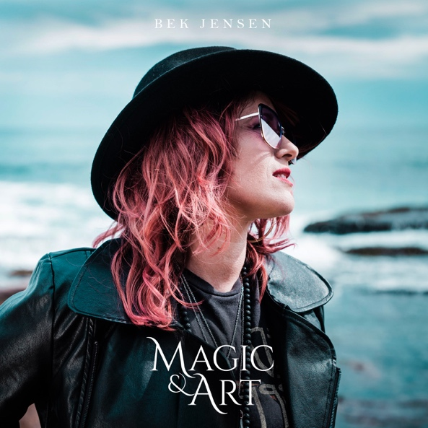
BEK JENSEN – MAGIC & ART
News …
Woman. Power. Love.
Sydney songwriter, Bek Jensen, has delivered her new EP - Magic & Art - with a whole lot of style and prowess.
Magic & Art is Bek's 3rd solo release. It is moving, heartfelt, identifiable and filled with 100% soul and, above all, good songs!
Tipping her hat to her musical roots, Bek’s sound has been likened to Janelle Monae, The Blues Brothers, Prince and the deep soul music that she was raised on.
Magic & Art is for the magician and artist in everyone!

SHORT BIO …
Sydney songwriter Bek Jensen, delivers her vocals in a way that is moving, heartfelt, identifiable, and filled with 100% soul. Already established as an in-demand backing vocalist from the age of 16, Bek has recorded and toured nationally with Australia’s iconic artists including Cold Chisel, Jimmy Barnes and Mahalia Barnes, Tina Harrod, The Sleepy Jackson, Jackie Orszaczky and Clayton Doley and Lachy Doley to name just a few and has released numerous original recordings, Bekimochi, Lucky and Magic & Art.

LONG BIO …
Bek Jensen grew up in an exceptionally talented family with both her parents working as professional musicians in Australia. Always surrounded by live music and wrapped in a blanket of classic soul, blues, jazz, country and gospel music, she started performing at a young age and found that she had an intense passion for the stage.
Already established as an in-demand backing vocalist from the age of 16, Bek has recorded and toured nationally with Australia’s iconic artists including Cold Chisel, Jimmy Barnes and Mahalia Barnes, Tina Harrod, The Sleepy Jackson, Paul McDermott, Jade MacRae, Morganics, Jackie Orszaczky and Clayton Doley and Lachy Doley to name just a few and has released numerous original recordings, signed and unsigned, under different guises.
In 2007 Bek teamed up with producer/composer/guitarist Marty Hailey (Lo-Tel, Jimmy Little, David Campbell, Smoke and Mirrors) to release an original album together titled Counting The Days by The Favourites.
In 2009, Bek and her husband, Michael Wheatley, built their own professional recording studio, Nut n Butter Studio in Marrickville and started preparing Bek’s first solo album release beginning with workshopping her songs, teaching vocals and gigging all over the country to raise funds for the project. In 2010 Bek was offered a 5-month singing contract in Japan which was the perfect opportunity to reconnect with her own unique sound.
On returning home with a suitcase full of new songs, Bek called upon Sydney’s finest musicians to bring their amazing talents to her music producing her first her solo album Bek Kimochi.
In 2014, Bek delivered a fresh new sound with a further EP - Lucky. Produced and co-written with Tim Hall (The Whitlams, Chakra Diva, The Strange), they started writing songs together and Tim opened many creative doors for Bek, allowing her to walk through ideas she may not have dared to on her own. The result was a bunch of fun, quirky and exciting songs that she calls organic, electro soul. The EP was also made on a successful crowdfunding campaign.
Performing in live venues all over Sydney as a solo artist, a duo and with her band Bek Jensen & The Gold Rockets, Bek has created an extraordinary journey for all her listeners to dance, sing and feel emotions to. Let’s be honest, there can always be more magic and art in the world.
Check out Bek Jensen’s latest EP, Magic & Art - out now on all popular music platforms!
For further information, please contact:
Bek Jensen: 0420 249 661 email: business@bekjensen.com

